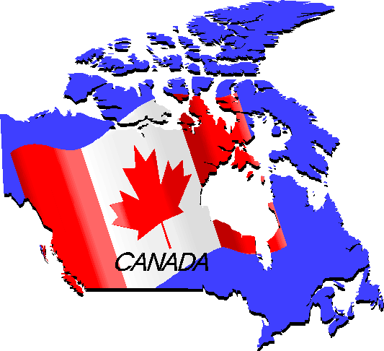
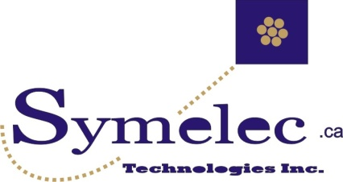
- Symelec Technologies Inc.
- 801 Des Aulnaies, Pincourt, Qc. J7V 0C7
- Tel. (514) 453-4789 Fax (514) 453-4344
- info@symelec.ca www.symelec.ca
  Building Wire  RW90  T90  Bare Copper  (Soft-Medium-Hard Drawn)  Tinned Copper  RWU  USE  Tracer Wire  Aluminum tie wire  www.republicwire.com |   Power cables  Mining cables ; G, G-GC, SHD-GC, Type W  Cords ; SOOW, SJOW, SJTW, SJEOOW,  Welding Cable  Type DLO, Type W  Stage Lighting (PPC)  www.tfcable.com |   Medium Voltage  High Voltage 46 – 345 KV  MV90/105  2G – 5000MCM  Copper & Aluminum  Industrial power cable  Airport Lighting  ACSR, URD  Fiber Optic Cable  www.synergycables.com
  FT6, Plenum-Rated Cable  Echelon approved cables,  Telecommunications cable  LSZH, VFD/Servo-Cable  Factory automation,  Process control  www.generalwireproducts.com |   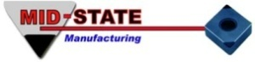  Power Cords, Accessories  Extension cords, booster cables  Power cords , accessories  Connectors, clamps, caps  Handles  www.cordsetsinc.com |   Electrical Conduit Fittings  Rigid conduit connectors couplings, liquid-tight connectors, cord grips, spectrum  Plastic connectors,  Bushings, washers  Reducing  www.americanfittingscorp.com
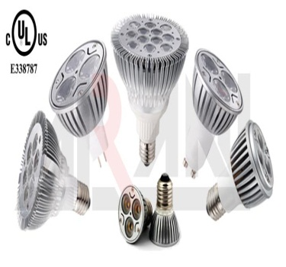 |     LED Lighting Products  Dimmable LED integrated  Fixtures & Bulbs  LED Tubes (Florescent replacement)  LED Strips  LED Streetlights & Solar Streetlights  Kits & accessories  www.arani.ca/en/products | 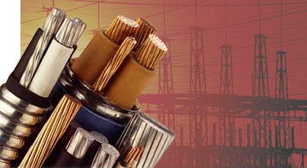
For all questions and inquiries, please contact your Symelec Sales representative today !
Tel (514) 453-4789 Fax (514) 453-4344
Canada’s #1 Agent for ALL Wire – Cable & Accessories ! Votre Agent #1 pour le Fil – Câbles & Accessoires !

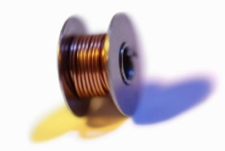
- Symelec Technologies Inc.
- 801 Des Aulnaies, Pincourt, Qc. J7V 0C7
- Tel. (514) 453-4789 Fax (514) 453-4344
- info@symelec.ca www.symelec.ca

Building Wire | Medium Voltage 5kV -35 kV | Utility Cables
Bare Copper  T90  RW90  Tinned Copper  RWU  USE | MV90/105  5 - 35KV  URD  Jumper Cable  Copper & Aluminum  Industrial power cable | High Voltage 46 – 345 KV  ACSR  URD  Bare Copper

Mining Cables | Flexible Single Conductors | Portable & Flexible Cords
Type W  Type G  Type GGC  Type SHD-GC  Type MP-GC  MPF | Welding Cable  Type DLO  Stage Lighting (PPC)  Type W  ...more | SSOOW  SJOOW  SJTW  SJEOOW  Drill Cord

Specialty Cables |  | LED Lighting Products | Hook-Up Wire
 | Boat Cable  RV Cable  Automotive Cable  Entertainment Cable  Control Cables  Submersible Cable  ...more | Dimmable LED integrated  Fixtures, LED Bulbs  LED Tubes, LED Strips  LED Streetlights & Solar Streetlights  Kits & accessories | ...more

Control, Audio & Specialty | Fire Alarm & Security | Communication Cable
24awg – 10awg  Multi-paired &  Multi-conductor  Shielded &  Non-Shielded | Fire Alarm  Intrusion  Access  Composite cable  Station Z | Multi-pair  Multi- conductor  Outside plant  734/735  Fiber Optic  Echelon

Low Voltage Cable
Multi-conductors
Speaker wire

Contact your Symelec Sales Representative for further details! (514) 453-4789

